Dear Parents and Carers.
We hope you are all well.
This letter is to let you know we are changing the way we invoice you here at [YOUR SETTING’S NAME].
From now on, invoices will be sent to you electronically via Tapestry. When this is done, you will receive an email which looks like this:

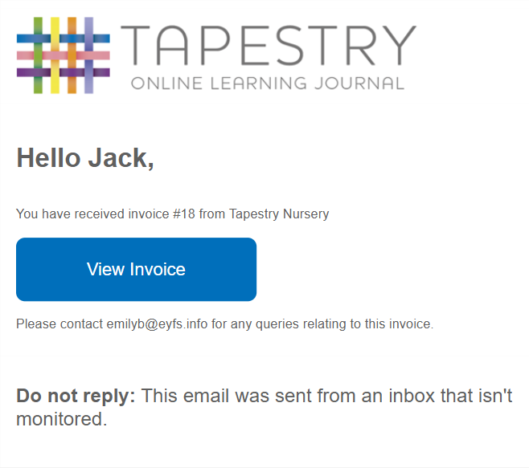

You just need to click the blue “View Invoice” button in this email to be taken to the PDF version of your invoice.
Your invoices will look similar to this:
Message to setting
Please note what is included on your invoice will depend on what settings you have enabled/disabled within the config section of your account (Booking -> Config -> Invoices). There you have the options to:
- Show your setting logo in the header
- Add custom header and footer text
- Set how many days after an invoice is generated that it becomes due
- Choose whether the balance brought forward is displayed
- Choose whether a regular schedule summary is displayed and if so, whether the rates are included
- Choose whether a detailed breakdown section is included and if so, whether the rates are included
The below screenshot was taken with all options enabled. Therefore it may not completely reflect what invoices generated for your setting look like.
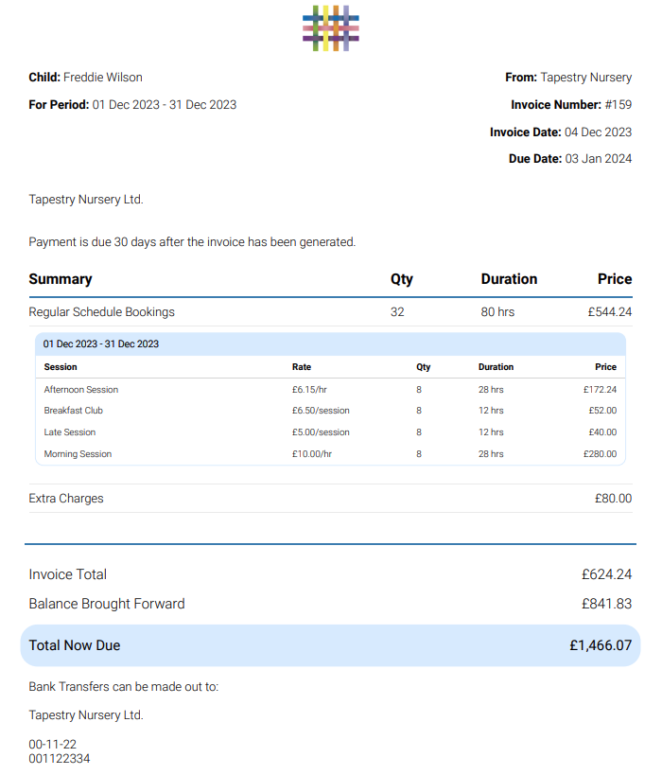
Optional if you include the detailed breakdown section
On any additional pages you will find the detailed breakdown of all charges included on the invoice.
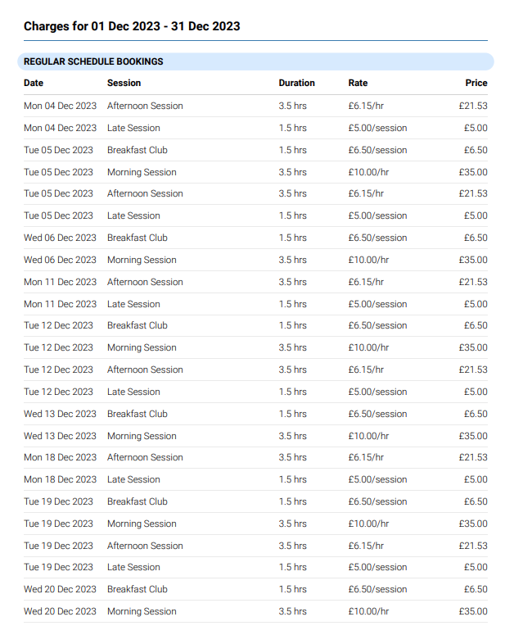

Payment details and methods remain unchanged.
When making payments, you will also receive your receipts via Tapestry. These receipts look like this:
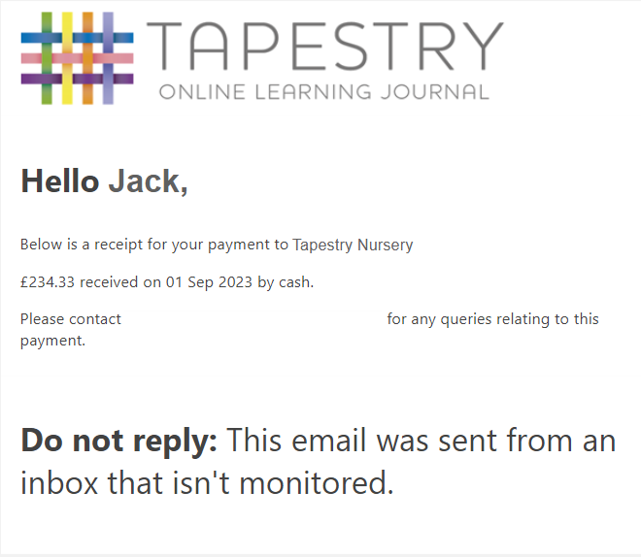

Thank you for your cooperation. As always, if you have any questions don’t hesitate to contact us.
Yours sincerely,

