Tapestry for Parents and Relatives: Web Browser Version Guide

Note on Terminology: ‘Setting’ is a generic term for an educational establishment or education setting, such as a school, nursery, day-care or childminders. Unless a distinction is made it does not refer to computer settings or options.

Where to find Tapestry

To access the web browser version of Tapestry go to www.tapestryjournal.com or follow this link if reading a digital version of this guide. You can also use a setting-specific link that staff at your child’s setting may have given you. Tapestry does not have high system requirements, but please make sure you update your web browser to the latest version available for the best user experience.

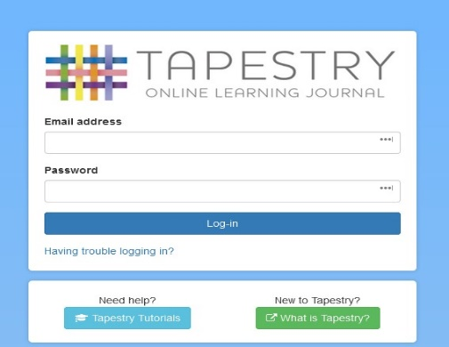
Login Information

In order to use Tapestry, your setting will have to create a user account for you on the system.
Tapestry support (the customer services team) are unable to create or modify relative accounts; if you have an issue with your Tapestry account please contact your setting. Tapestry support can only directly provide parents and relatives with basic advice on how to use the system.

Your Username: This will be the email address your setting used to register you on Tapestry, for example jparent@example.co.uk.

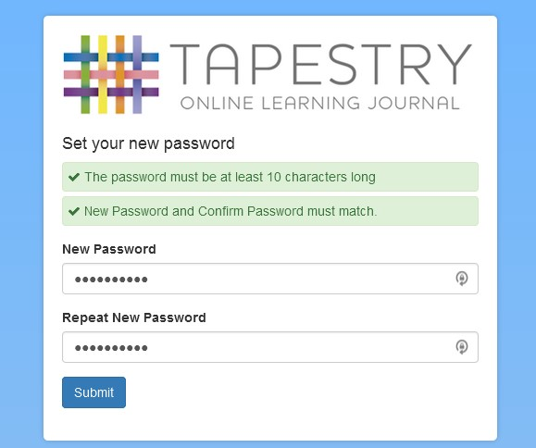
Your Password: You will get your password in one of several ways:

- You will receive an email generated by your setting that contains a link you can follow to set up your own password and PIN number for Tapestry. This link will expire 30 days after it has been sent. If your link has expired or won’t work for another reason, please contact your setting manager for assistance.
- Your password will already have been set by your setting. You will receive it in written form, or in an email sent by setting staff. If the setting is printing this tutorial off for you, it may also be written here:
- You can change both your email and password through the browser version of Tapestry whenever you like.
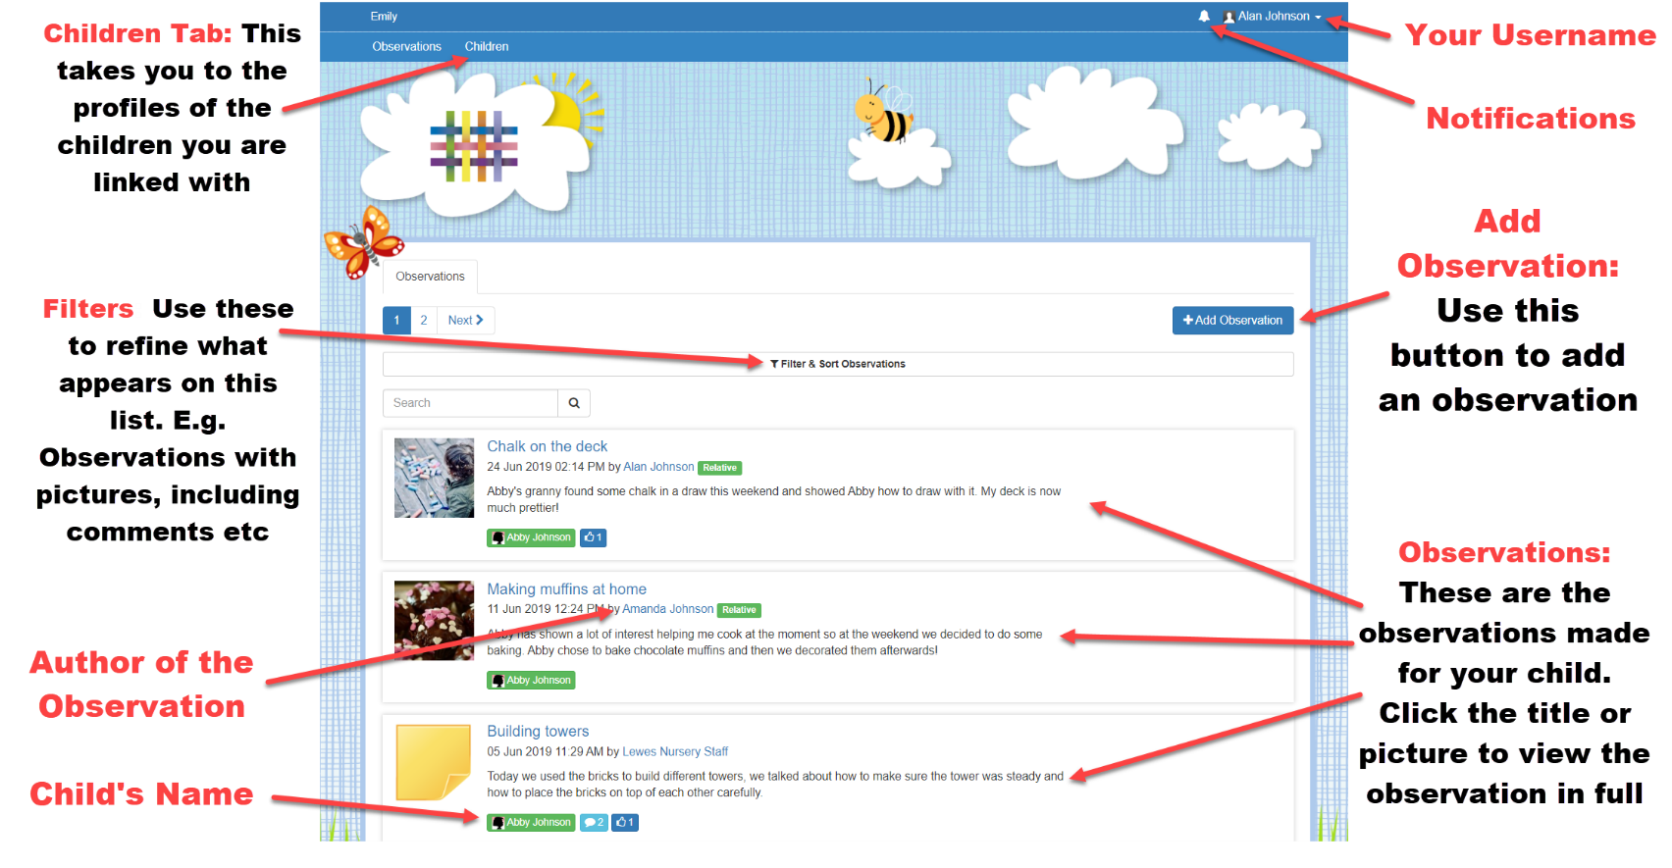
Tapestry Browser Version Interface: Observations Screen

Your Username

Access this drop-down menu by clicking on your username in the top right of the screen
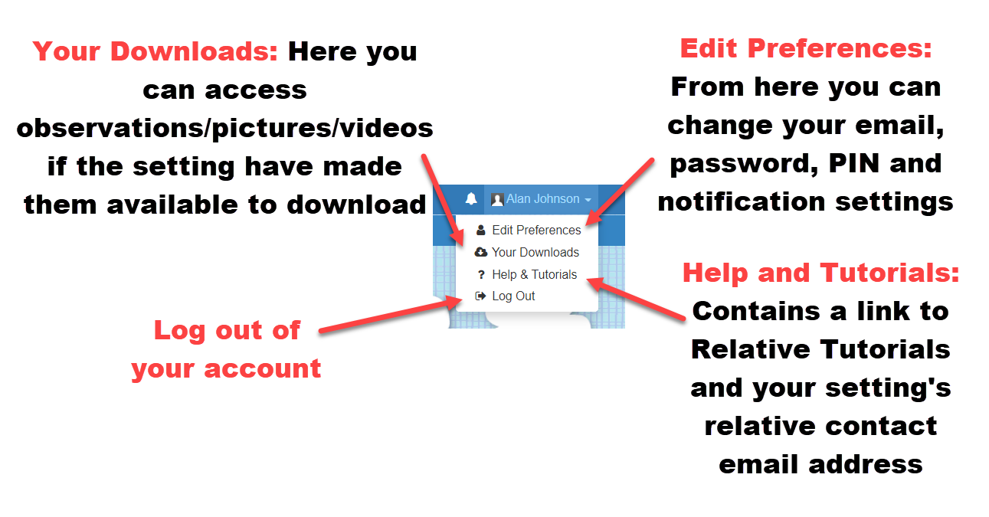

Viewing an Observation

To view an observation, click on the observation title or thumbnail image of an observation on the ‘Observation’ page.

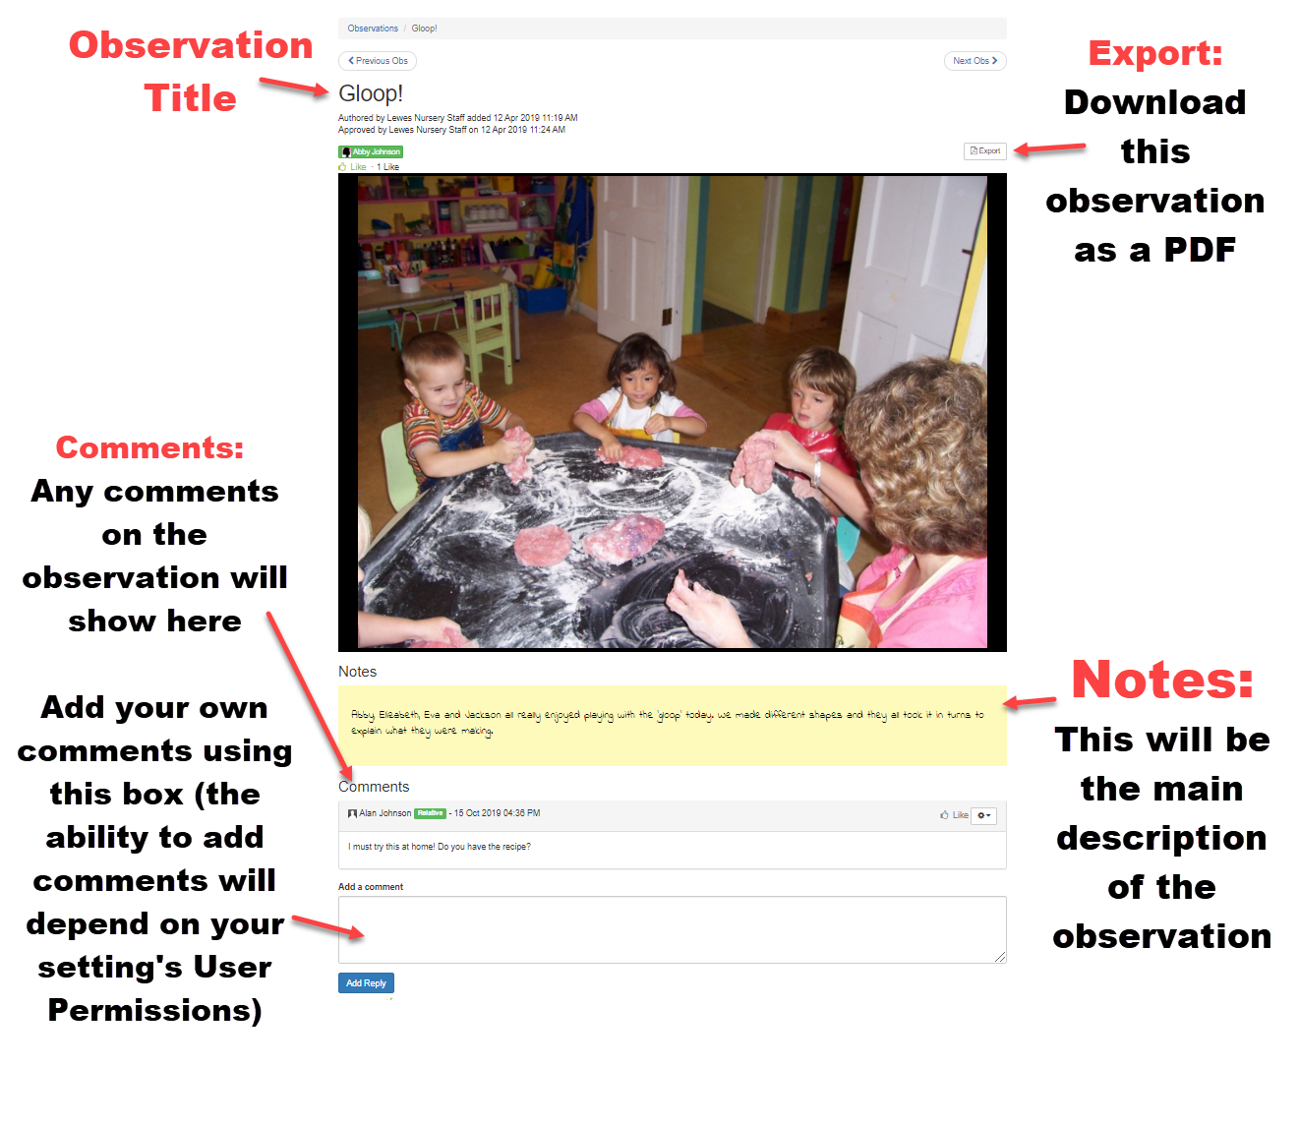

Making an Observation
Press the ‘Add Observation’ button on the observations page to add a new observation yourself. Please note, you must add a title and select a child in order to save the observation.
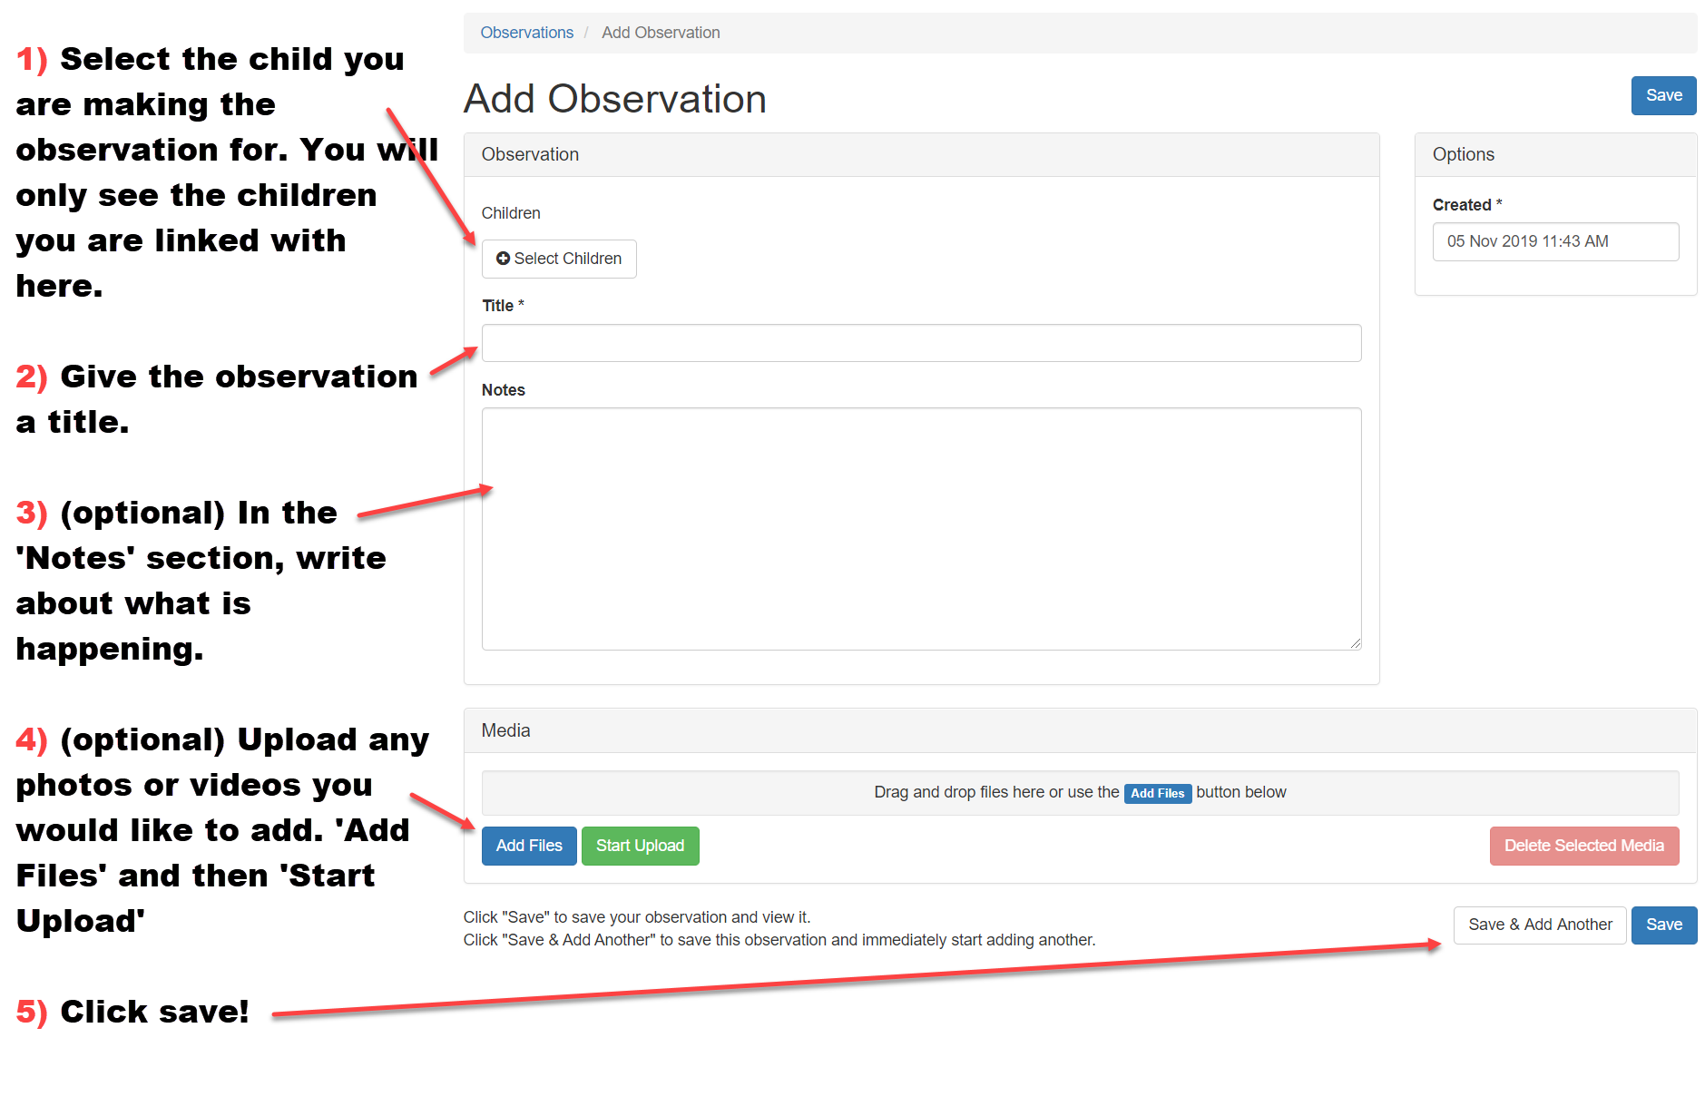

Viewing Reports

- Click on the ‘children’ tab at the top of the homepage.
- Click the name of the child whose reports you would like to see.
- Click on ‘Reports’.
- Click on the title to view the report in full.
This will take you to this screen where you can view, comment and upload documents to reports (provided the report is not locked and you are permitted to do so).
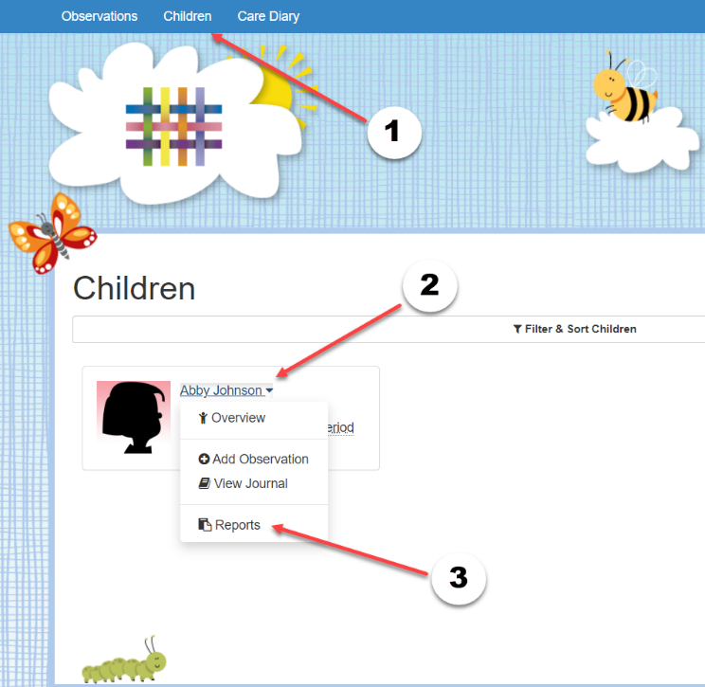

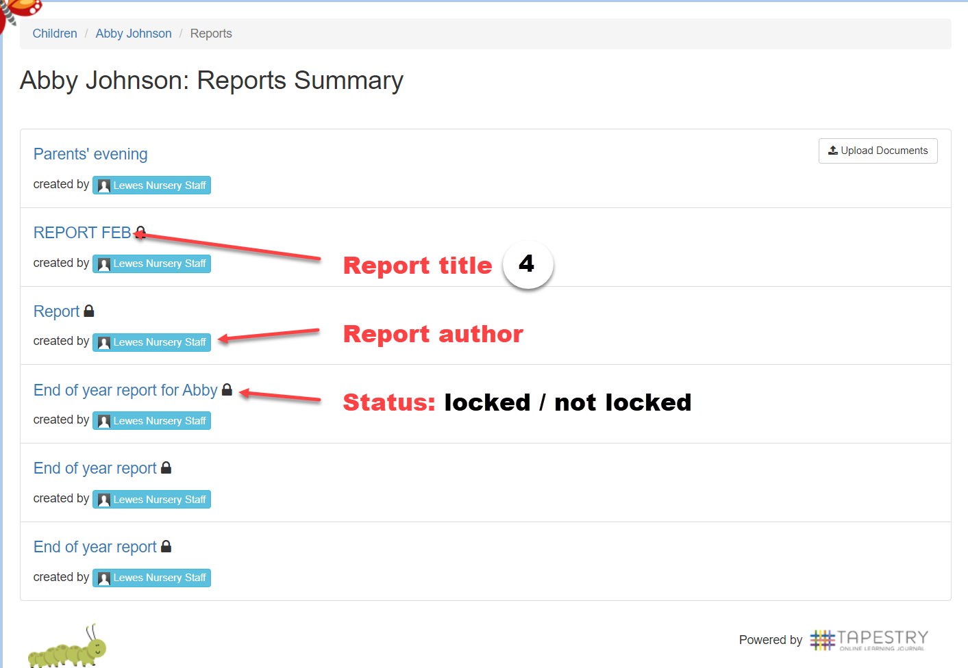

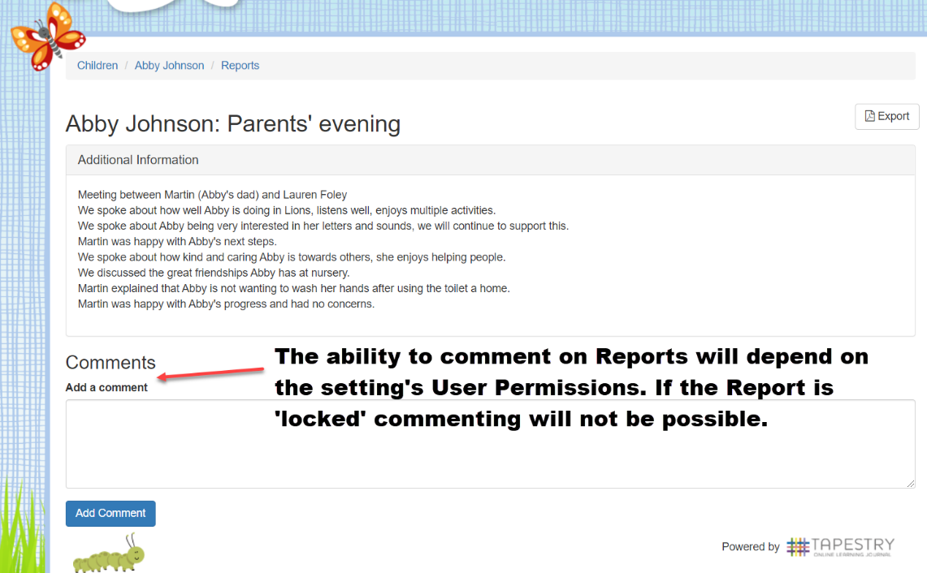

OPTIONAL: Documents

The setting may upload documents to Tapestry and make them available for you to view and download.

In order to do this, click the “Documents” tab on the homepage (1)
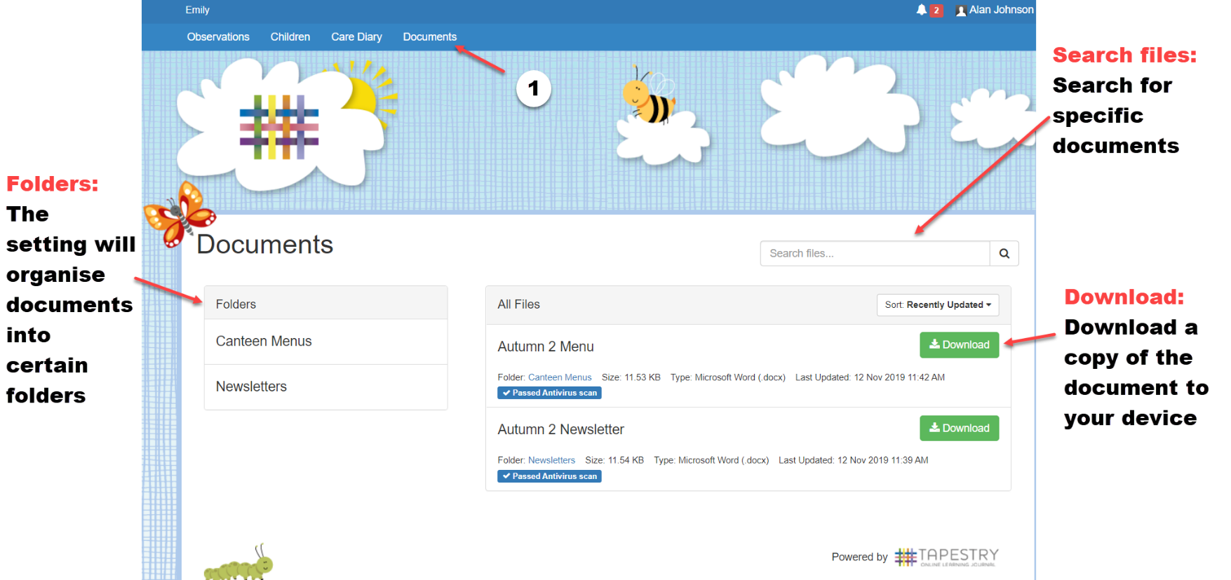
OPTIONAL: Memos

The setting may use the Memos feature to share news and updates about your child/ren with you. And some Memos may also have media attached. You can view your Memos by clicking ‘Memos’ on the top bar on the homepage.

You will see a list of the Memos, and can click on the title of one to view (1)
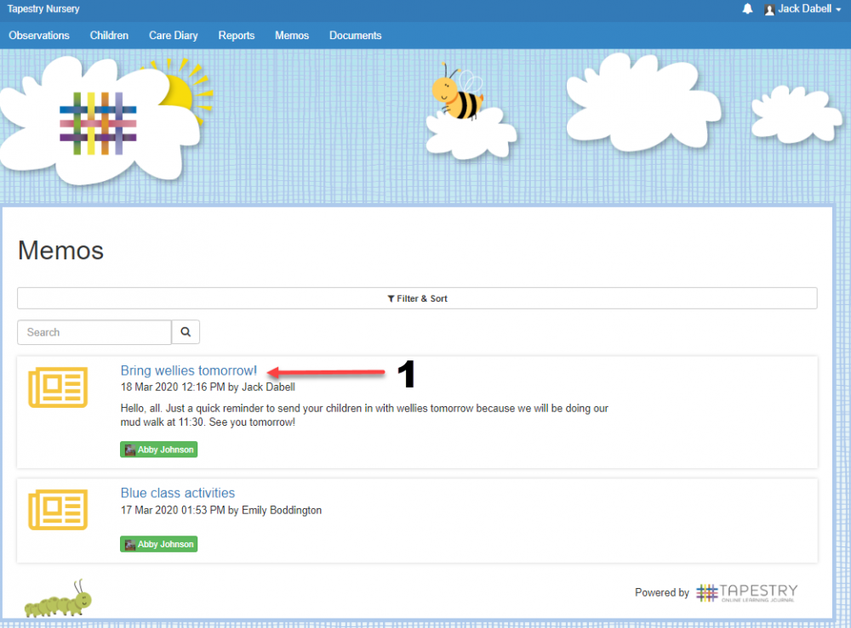

If you’ve been permitted, you can then like (1) and comment (2) on the Memo, and also export it to PDF (3)
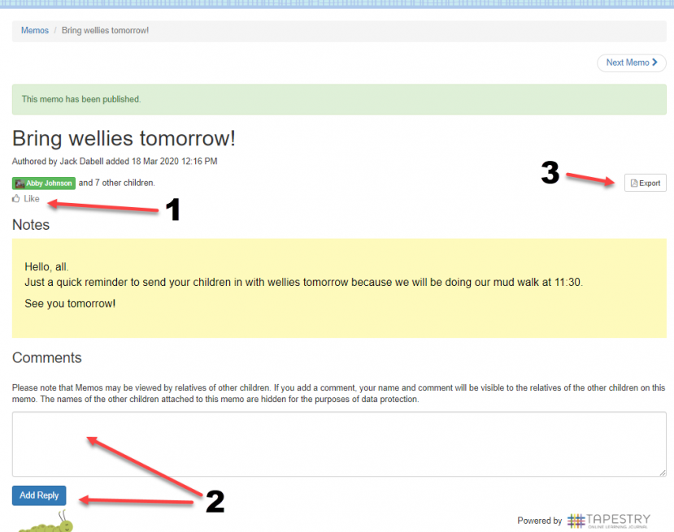

OPTIONAL: The Care Diary

Your setting may be using the Care Diary on Tapestry. This page allows practitioners to log toileting, feeding, sleeping and accidents. There is also a comment feature. Your access to this feature will depend on the setting’s choice.

If you are permitted to see the Care Diary, there will be a button on the homepage next to ‘Observations’ and ‘Children’. Click that and, if entries have been made already, you will see a page that looks like this:

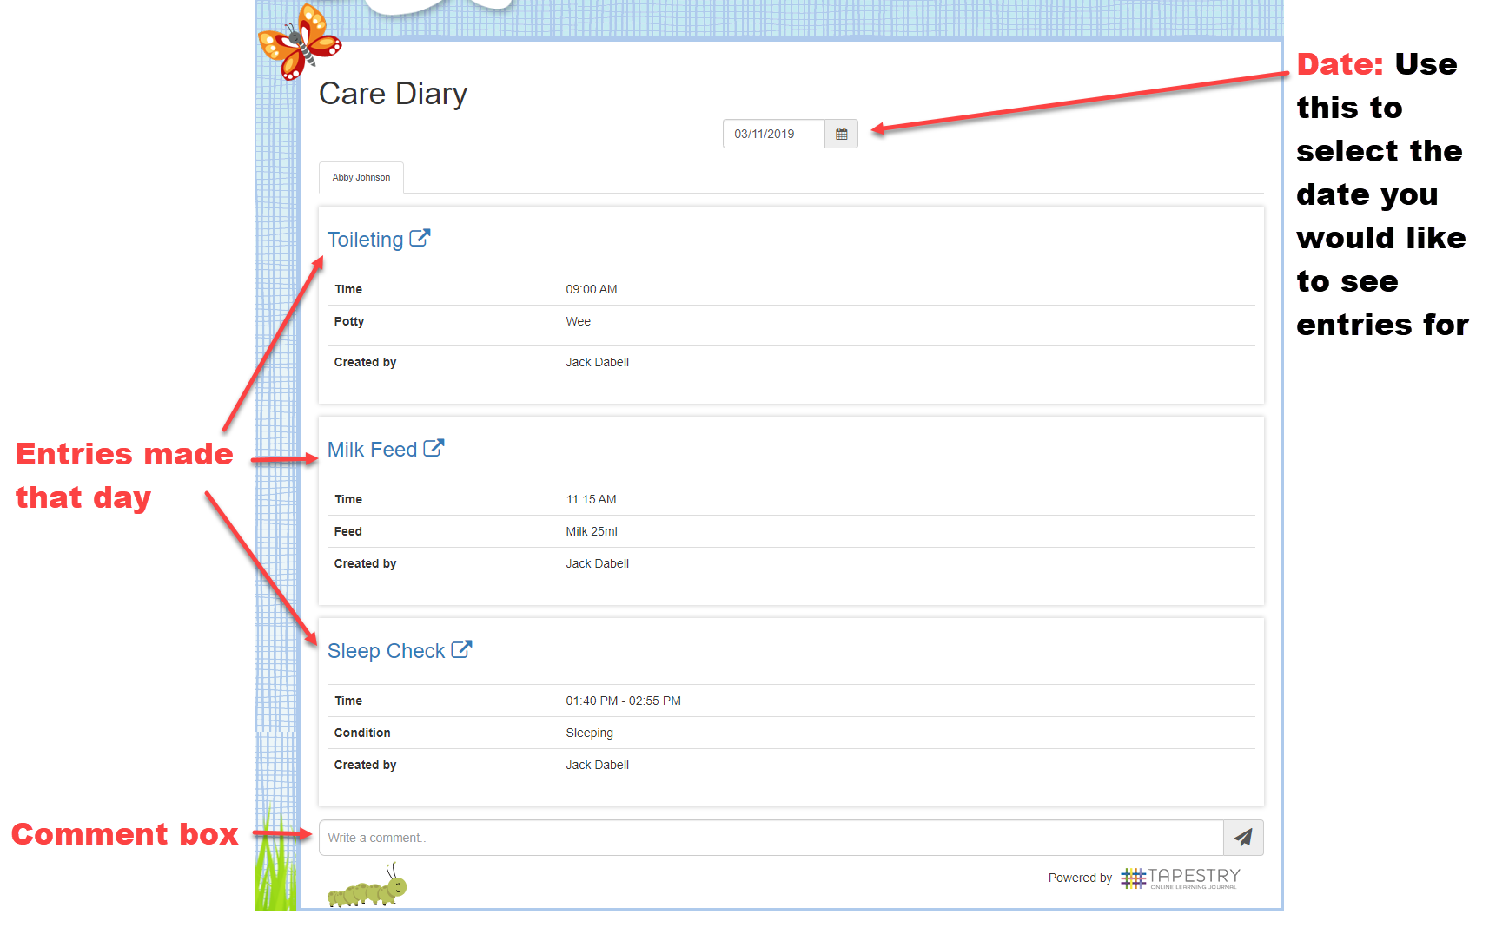

OPTIONAL: Accidents

The setting may be using the Accidents function to record and share any accidents that have occurred whilst your child/ren is in their care.

You can access this by clicking ‘Accidents’ in the top banner from the homepage, where you will see information about any accident’s that have occurred during the select date (1).

There is also a comments tool which you can use to send messages back and forth between yourself and your child/ren’s setting (2).
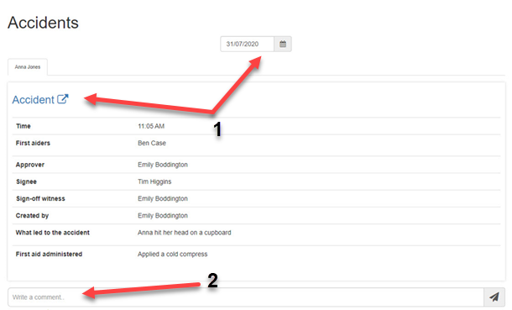

OPTIONAL: Activities

Your setting may use the Activities feature to set home learning activities. You can access these from ‘Activities’ on the top banner.

You can view set activities in the Planned Activities section (1). If you click on a title (2) you can view the notes for the activity (3), along with media your setting may include (4). You can add a comment if permitted (5), or once the activity has been completed by your child/ren, you can send it back to the setting through an observation (6).
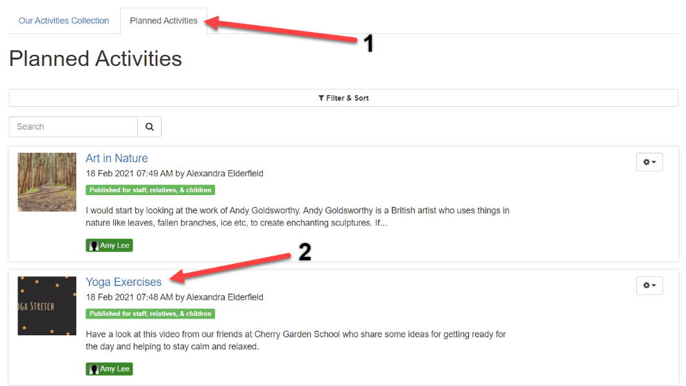

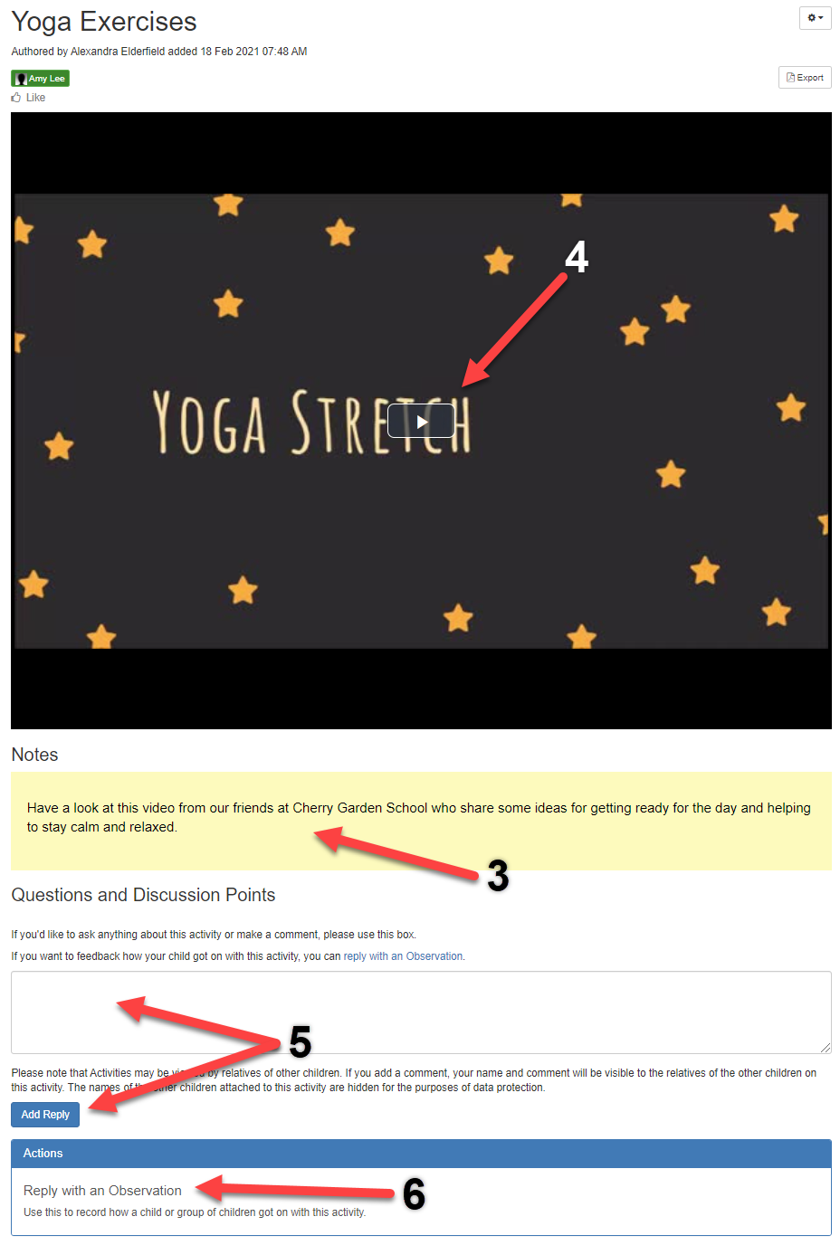

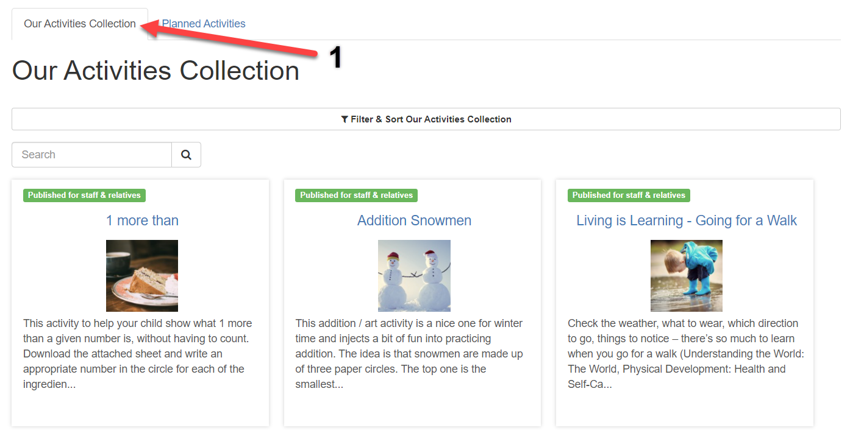
There is also Our Activities Collection (1) where you can view your setting’s bank of activity ideas, you can look through there for inspiration.

OPTIONAL: Notifications

If permitted, you can change your own preferences to set whether and how you’re notified about different account activity, such as a new observation comment.

To access these settings, click on your name at the top (1) and go to ‘Edit Preferences’ (2). Then ‘Change Notification Preferences’ (3).
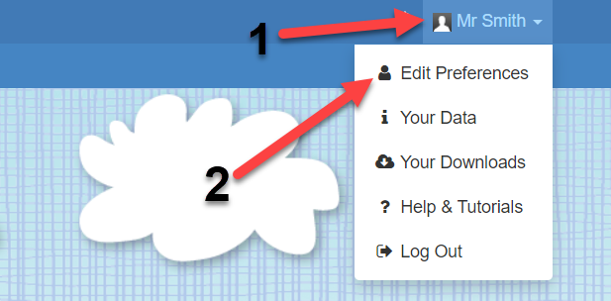

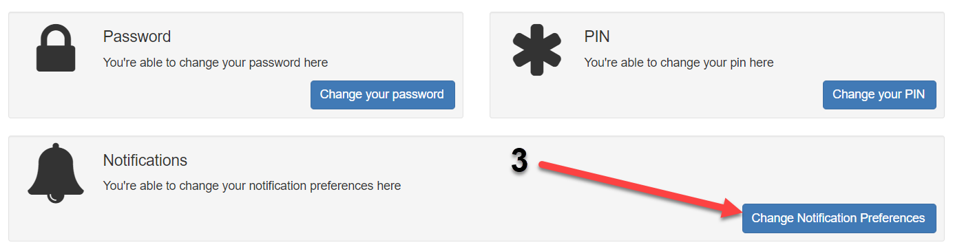

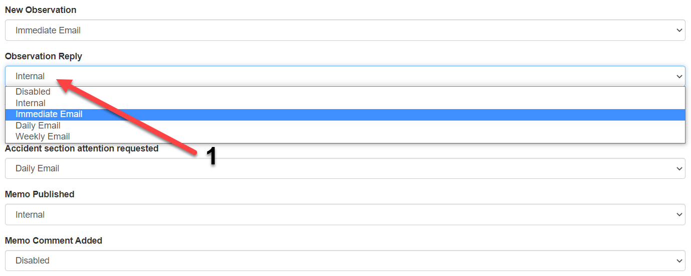
Just click on the notification you’d like to change and select a new preference (1).
If you’d like to be notified only on Tapestry, then you can choose ‘Internal’. Or to be notified also by email then select ‘x Email’ to receive email notifications either immediately, daily or weekly if there are new entries for you to view.
OPTIONAL: Child Login

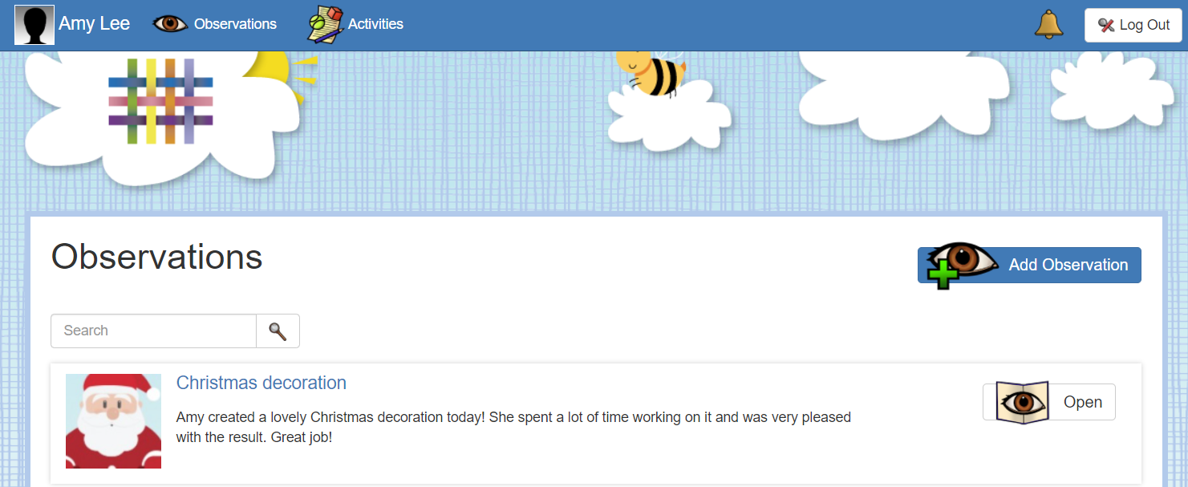
Your child/ren will be able to login to their own Tapestry account at the location of their setting. Here they can respond directly to the observations and activities set for them, and create their own entries.

If permitted, you can also log your child/ren into their account/s through your own login at home. To do this, after you’ve logged into your own account, click ‘Child Login’ on the top bar (1), and select ‘Log out & switch to child’ (2).
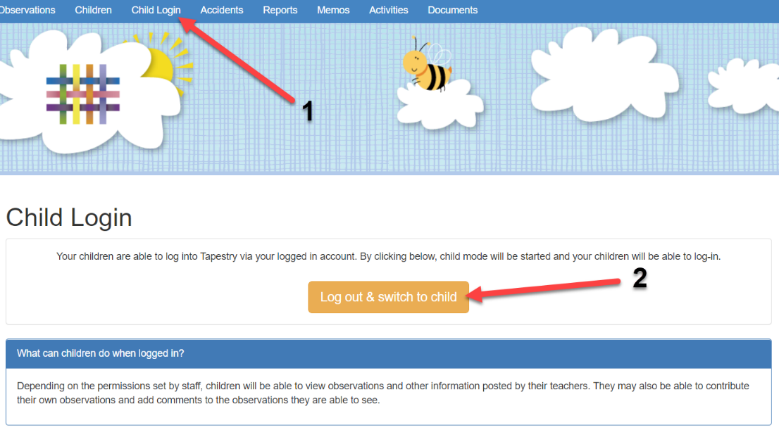

Select your child (1), and they may need to enter their own password to login (2).
